**Design Thinking Project Workbook**

**Don't find customers for your product but find products for your customers**

**1. Team**

**Team Name:** **Dementia Detective**

**Team Logo (if any):**

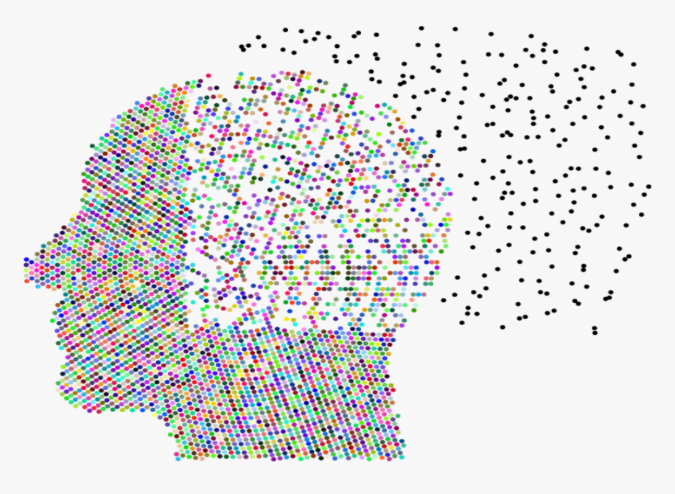

**Team Members:**

1. V.Sai
2. K.Harshavardhan
3. A.Mukesh
4. D.Manideep

**2. Problem/Opportunity Domain**

**Domain of Interest:**

In the domain of dementia prediction using machine learning (ML), the focus would likely be on healthcare, particularly in early detection and prevention of neurodegenerative diseases. This could involve applying ML to analyze medical data, such as brain scans, genetic information, and lifestyle factors, to predict the onset of dementia.

**Description of the Domain: .**

**Medical Imaging:** MRI, PET scans to identify early structural changes in the brain.

**Genetic Data:** APOE gene and other genetic markers associated with dementia risk.

**Cognitive Tests:** Standardized tests such as the Mini-Mental State Exam (MMSE) for tracking cognitive decline.

**Data Privacy & Security:** Handling sensitive medical data poses significant privacy concerns, requiring strict adherence to regulations like HIPAA.

**Data Quality & Availability:** High-quality, labeled data is necessary for effective model training. Missing, incomplete, or biased datasets can lead to inaccurate predictions.

**Why did you choose this domain?:**

**Improving Patient Outcomes:** Dementia is a growing global health issue, affecting millions of individuals and their families. Early detection could delay the onset and progression of the disease, enhancing the quality of life for patients.

**Aging Population:** With the global population aging, the incidence of dementia is expected to rise sharply. By 2050, over 130 million people are projected to suffer from dementia globally. There is significant demand for better diagnostic and predictive tools.

**Lack of Early Detection Tools:** Currently, most dementia diagnoses happen after significant cognitive decline has occurred, limiting treatment options. ML models can help identify individuals at risk before symptoms are clinically observable.

**3. Problem/Opportunity Statement**

**Problem Statement:**

**Delaying Progression:** Early prediction enables timely interventions such as medication, cognitive therapy, and lifestyle changes, which can delay the progression of dementia, potentially preserving cognitive function for longer periods.

The problem, therefore, is the lack of accessible, accurate, and early-stage prediction tools for dementia.

**Problem Description:**

Dementia is typically diagnosed only after noticeable cognitive decline has occurred, by which time treatment options are limited and less effective. Current diagnostic methods rely heavily on clinical assessments, brain imaging, and cognitive tests that often detect dementia too late for early intervention. Additionally, these methods struggle to handle the vast and complex medical data required to accurately predict dementia risk in its earliest stages.

**Context (When does the problem occur):**

Dementia is often diagnosed only after cognitive symptoms become apparent, such as memory loss or confusion. By this time, the disease has usually progressed to a stage where interventions are less effective.

**Alternatives (What does the customer do to fix the problem):**

These alternatives are either reactive or offer limited predictive capabilities, often leaving patients with few effective options for early-stage intervention. The goal of ML-based dementia prediction is to provide more proactive, precise, and scalable tools for early detection.

**Customers (Who has the problem most often):**

Caregivers, particularly family members of individuals showing early signs of cognitive decline, are deeply affected by the delay in diagnosis and the uncertainty surrounding disease progression. They are often the first to notice symptoms and seek more efficient tools for early detection.

**Emotional Impact (How does the customer feel):**

These emotional impacts highlight the urgent need for more effective, early-stage dementia prediction tools, as they address deep-seated fears, frustrations, and desires for greater control and clarity over a complex and distressing condition.

**Quantifiable Impact (What is the measurable impact):**

Rising Global Costs.

High Per-Patient Cost.

Healthcare System Strain.

**Lost Productivity for Caregivers.**

**Increased Long-Term Care Facility Demand.**

**Alternative Shortcomings (What are the disadvantages of the alternatives):**

**1)Delayed Diagnosis and Intervention**

**2)Limited Home Care Options:**

**3)Cost Barriers**

**4)nadequate Training for Caregivers**

**5)Capacity Limits**

**Any Video or Images to showcase the problem:**

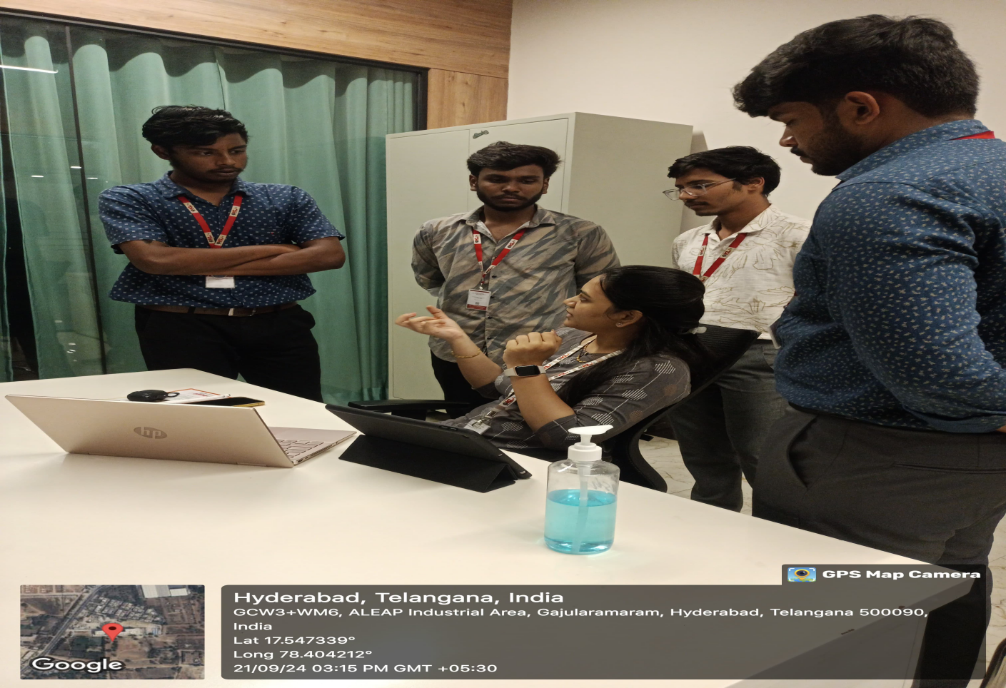

**3. Addressing SDGs**

**Relevant Sustainable Development Goals (SDGs):**

**Good Health and Well-Being**

* This goal aims to ensure healthy lives and promote well-being for all at all ages. Early dementia prediction can significantly improve health outcomes, allowing for timely interventions that enhance the quality of life for patients and their families.

**How does your problem/opportunity address these SDGs?:**

**Good Health and Well-Being**

* **Improved Health Outcomes:** By implementing machine learning tools for early dementia prediction, healthcare providers can identify at-risk individuals sooner. This leads to timely interventions that can slow disease progression, reduce complications, and enhance overall patient well-being.
* **Preventive Care Strategies:** Early detection allows for the development of personalized preventive care plans, ultimately reducing the incidence of severe dementia and related health issues.

**4. Stakeholders**

Answer these below questions to understand the stakeholder related to your project

1. **Who are the key stakeholders involved in or affected by this project?**

Patients, families, healthcare providers, researchers, technology developers, policymakers, caregivers, and insurance companies.

1. **What roles do the stakeholders play in the success of the innovation?**

Patients seek timely diagnosis; healthcare providers need reliable tools; researchers aim for funding and data access

1. **What are the main interests and concerns of each stakeholder?**

Patients seek timely diagnosis; healthcare providers need reliable tools; researchers aim for funding and data access.

1. **How much influence does each stakeholder have on the outcome of the project?**

Patients and healthcare providers have high influence; technology developers and policymakers also play significant roles.

1. **What is the level of engagement or support expected from each stakeholder?**

Active engagement from patients and families; collaborative support from healthcare providers and researchers.

1. **Are there any conflicts of interest between stakeholders? If so, how can they be addressed?**

Patients may seek more care than insurance covers; address this through advocacy and negotiations.Use regular updates, feedback loops, and stakeholder meetings to maintain engagement and share progress.

1. **How will you communicate and collaborate with stakeholders throughout the project?**

Use regular updates, feedback loops, and stakeholder meetings to maintain engagement and share progress.

1. **What potential risks do stakeholders bring to the project, and how can these be mitigated?**

Resistance to change can occur; mitigate through training and demonstrating benefits of the prediction tools.

**5. Power Interest Matrix of Stakeholders**

**Power Interest Matrix: Provide a diagrammatic representation of Power Interest Matrix**

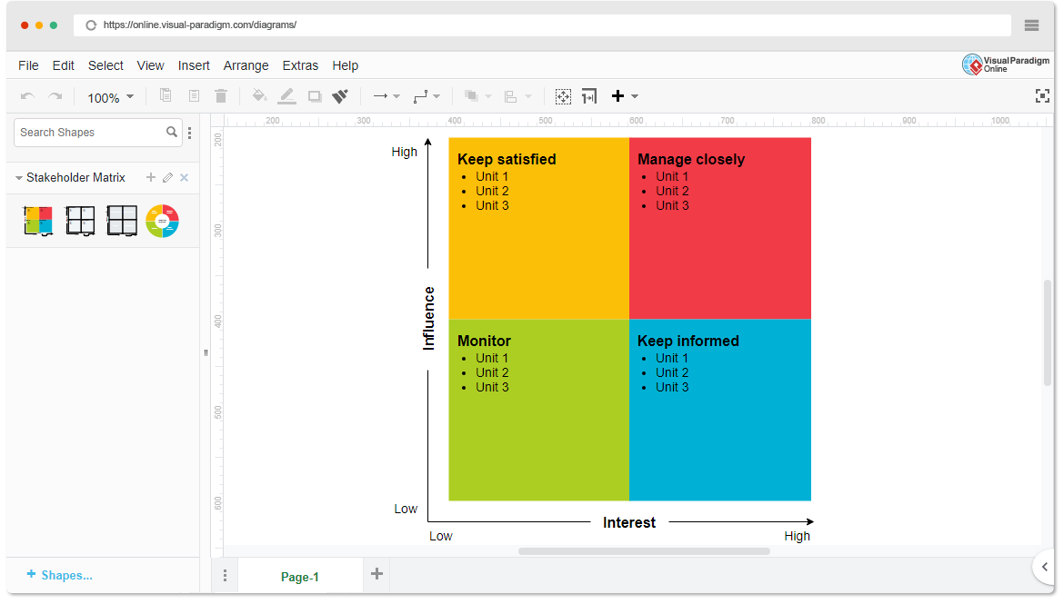

* High Power, High Interest: [GOVERNMENT HEALTH AGENCIES]
* High Power, Low Interest: [PHARMACEUTICAL COMPANIES]
* Low Power, High Interest: [FAMILY CAREGIVERS]
* Low Power, Low Interest: [GENERAL PUBLIC]

1. **Empathetic Interviews**

**Conduct Skilled interview with at least 30 citizens/Users by asking open ended questions (What, why/How etc) and list the insights as per the format below**

|  |  |  |
| --- | --- | --- |
| **I need to know**  **(thoughts, feelings, actions)** | **Questions I will ask**  **(open questions)** | **Insights I hope to gain** |
| Thoughts | What are your thoughts on your daily routine? | Understanding how they perceive their day-to-day life |
|  | What do you think about when you feel confused or forgetful? | Insights into how dementia affects their thinking patterns |
|  |  |  |
| Feelings | |  | | --- | | How do you feel when you forget things or feel disoriented? |  |  | | --- | |  | | |  | | --- | | Grasping their emotional response to memory loss |  |  | | --- | |  | |
|  | |  | | --- | | How do you feel about your current level of independence? |  |  | | --- | |  | | |  | | --- | | Insight into their emotional needs and independence concerns |  |  | | --- | |  | |
|  |  |  |
| actions | How do you handle situations when you cannot remember something? | Understanding coping mechanisms and actions they take |
|  | What do you do when you get frustrated or overwhelmed? | Understanding how they deal with emotional stress related to dementia |
|  |  |  |

**SKILLED INTERVIEW REPORT**

**(Examples are given. Erase them and fill with your user information.)**

|  |  |  |
| --- | --- | --- |
| **User/Interviewee** | **Questions Asked** | **Insights gained (NOT THEIR ANSWERS)** |
| Team:**Dementia Detective** | How challenging is it for you to care for a loved one with  dementia | Caregivers find it emotionally draining and often feel unsupported |
| Team:**Dementia Detective** | What emotions do you experiences secing your parents  Deal with dementia | . Family members often feel helpeless  And overwhelmed as the disease progresses |
|  |  |  |
|  |  |  |
|  |  |  |

**Key Insights Gained:**

* **Financial Burden of Care**

**Emotional and Physical Toll on Cargiver**

**Importance of community support Programs**

**`Empathy Map**

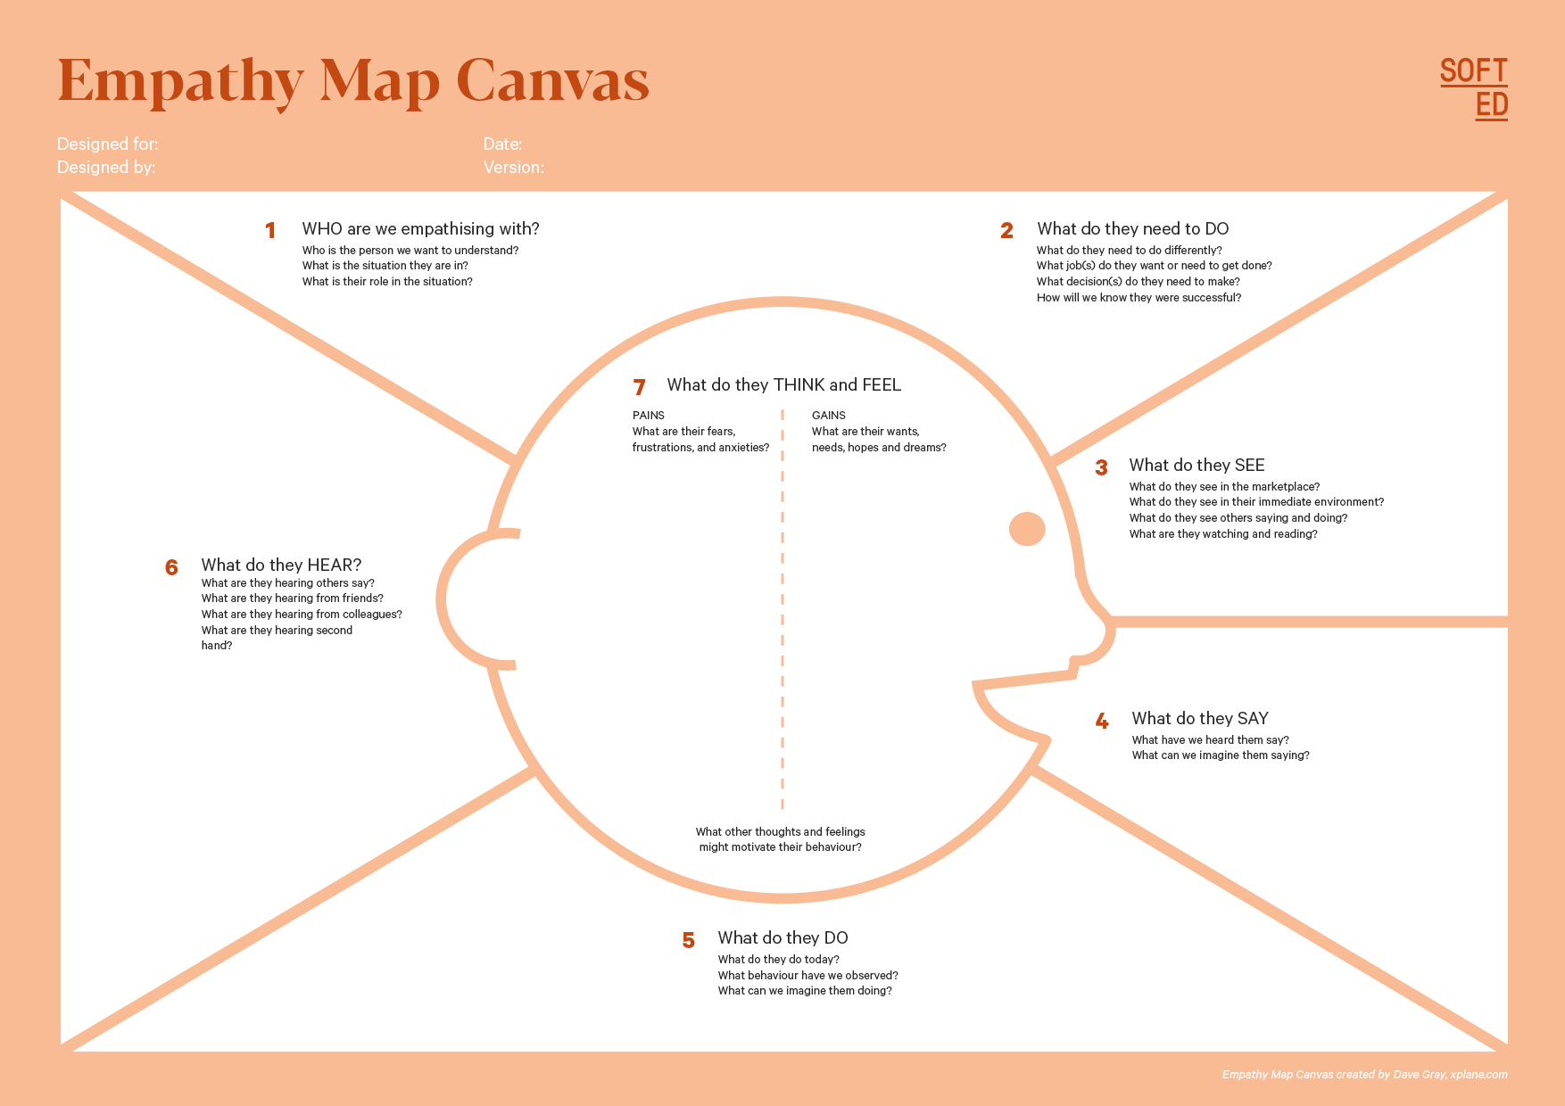

Your Answer:This section focuses on the auditory stimuli that individuals with dementia encounter in their daily lives, including conversations, background noises, and other sounds in their environment

Your Answer:Caregivers of dementia patients.

Caregivers of dementia patients

DEMENTIA PREDICTION USING ML

Designed By: **DementiDetectiveDetectiveDetectiveDetectiveDetective**d```dd**DdddekmvknvjknvjddddDetectiveDetectiveeDetective**

Date of Submission: 22/09/24

Your Answer:This section delves into the internal thoughts and emotional experiences of individuals with dementia

Your A It focuses on how they process their condition, their sense of identity, and the emotions they feel as they navigate daily challengesnswer:

Your Answer: It focuses on how they process their condition, their sense of identity, and the emotions they feel as they navigate daily challenges

Your Answer:They need to seek and utilize trustworthy resources about dementia care, treatment options, and support systems.

Your Answer:the patient faces, such as confusion, forgetfulness, and changes in behavio

Your Answer:Their speech may include repeated questions, incomplete thoughts, or expressions of anxiety about forgetting names, events, or places

Your Answer:People with dementia may often express confusion, frustration, or concern about memory loss, disorientation, or challenges they face.

1. **Empathy Map**
2. **Who is your Customer?**

Caregivers of dementia patients

**Key points:**

* **Define the customer profile clearly (e.g., age, profession, interests).**

**Age:** 35-65 years

**Profession:** Family members (spouses, children) or professional caregivers (nurses, home health aides)

**Interests:** Health and wellness, effective caregiving strategies, support groups, technology for healthcare

* **State their goals and needs related to the innovation or product.**
* **Early Detection:** Desire for tools that help identify early signs of dementia to plan care effectively.
* **Resource Accessibility:** Need for easy access to information and support resources for managing dementia.
* **Emotional Support:** Seeking connections with other caregivers for shared experiences and emotional relief.
* **Quality Care:** Aim to provide the best possible care while maintaining their own well-being.
* **Context in which the user will interact with your solution.**

**Home Environment:** Caregivers will use the solution while managing daily routines, requiring user-friendly interfaces and straightforward access to information.

**Healthcare Settings:** Interaction may also occur in clinics or hospitals during consultations with healthcare providers.

**Support Groups:** Use of the solution in group settings, such as community centers or online forums, to share insights and experiences with other caregivers.

1. **Who are we empathizing with?**

Caregivers of dementia patients.

**Key points:**

* **Define the user's characteristics (e.g., personality, values, and responsibilities).**
* **Personality:** Compassionate, nurturing, and dedicated; often resilient but may experience stress and anxiety due to their responsibilities.
* **Values:** Strong commitment to family and caregiving; prioritize empathy, support, and the well-being of the patient above personal needs.
* **Responsibilities:** Manage daily care tasks, coordinate with healthcare professionals, and often balance these duties with personal or professional obligations.
* **State the user's goals and challenges in their environment.**

**Provide Quality Care:** Aim to ensure the patient maintains comfort, dignity, and quality of life.

**Seek Knowledge and Resources:** Desire to access reliable information about dementia and effective caregiving strategies.

**Maintain Personal Health:** Strive to prioritize their own well-being, preventing burnout and ensuring they can continue providing care.

* **What is the user's broader situation (professionally or personally)?**
* **Professionally:** Many caregivers may be employed in jobs that require additional time and energy, complicating their ability to focus solely on caregiving.
* **Personally:** Caregivers often have multiple roles (e.g., parent, employee) that can create additional stress, leading to a need for effective coping strategies and support networks.

1. **What do they need to DO?**

**Access Reliable Information:**They need to seek and utilize trustworthy resources about dementia care, treatment options, and support systems.

**Develop Care Plans:**Caregivers must create and adapt individualized care plans that cater to the specific needs of the dementia patient, considering both their physical and emotional well-being.

**.Key points:**

* **Clarify the tasks or actions the user needs to complete.**
* **Information Gathering:**
* Research and compile resources on dementia, caregiving strategies, and available support services.
* **Daily Care Management:**

Execute daily routines, including medication administration, meal preparation, personal hygiene, and mobility assistance.

**Communication with Healthcare Providers:**

Schedule and attend medical appointments, discussing the patient’s condition and any concerns with doctors and specialists.

**Care Plan Development:**

Create and regularly update personalized care plans based on the patient’s evolving needs and preferences.

* **What decisions do they need to make?**
* **Care Approach:** Decide on the best strategies for managing the patient’s care, balancing their needs with available resources.
* **Resource Utilization:** Determine which resources, tools, and support systems to leverage for effective caregiving.
* **Crisis Management:** Make quick decisions during emergencies or changes in the patient’s condition, prioritizing safety and health.
* **How do they define success or failure in their tasks?**

**Success:** Caregivers define success as the patient maintaining a good quality of life, showing comfort and happiness, and successfully managing daily tasks without excessive stress.

**Failure:** They may view failure as the patient experiencing significant distress, deterioration in health, or the caregiver feeling overwhelmed and unable to cope.

1. **What do they SEE?**

* Caregivers observe the daily difficulties the patient faces, such as confusion, forgetfulness, and changes in behavior, which can be distressing for both the caregiver and the patient.

**Key points:**

* **What do users see in their physical and digital environment?**

People with dementia often rely on visual cues for orientation and comfort. In their physical environment, familiar objects, clear signage, contrasting colors, and organized spaces can provide stability, while clutter or confusing layouts may increase disorientation or anxiety.

* **What trends or competitors do they notice?**

Unlike typical consumers, individuals with dementia may not consciously notice trends or competitors, but they might respond to familiar brands, simple packaging, or comforting colors and images. Their focus tends to be on what feels familiar and safe, rather than on new trends or competitive products in a traditional sense.

* **How do these visual elements influence their behavior?**

Visual elements can significantly affect a person with dementia’s emotional state and behavior. Familiar and organized environments can promote calmness and reduce agitation, while cluttered or chaotic spaces may cause confusion and restlessness. In both physical and digital environments, clear and simple visual cues can encourage independence, while overwhelming designs can lead to anxiety or withdrawal.

1. **What do they SAY?**

Their speech may include repeated questions, incomplete thoughts, or expressions of anxiety about forgetting names, events, or places. However, they may also share positive memories or talk about past experiences that remain vivid to them.

**Key points:**

* **What might users express openly in conversation about their problems?**

Individuals with dementia may openly share confusion, frustration, or concern about memory lapses, difficulty recognizing people or places, or struggling with tasks they used to perform easily.

* **How do they express their goals or frustrations?**

People with dementia might express frustration by saying things like, "I just want to remember things like I used to," or "I feel lost and I don’t know why." They may also express goals in a simple and straightforward manner, such as "I want to stay independent," or "I just want to feel normal."

* **What are their words during customer interviews or feedback?**

In structured settings like interviews or feedback sessions, individuals with dementia might say things like, "I get frustrated when I can't find the right words," or "It helps when things are simple and easy to follow."

1. **What do they DO?**

This section focuses on the observable actions and behaviors of individuals with dementia in various situations, especially when interacting with their environment, caregivers, and technology. Understanding their actions helps caregivers and professionals interpret their needs, frustrations, and coping mechanisms.

**Key points:**

* **What observable actions do users take?**

People with dementia often exhibit behaviors like repeating questions, retracing their steps, or searching for misplaced items. They may check clocks or calendars frequently, or ask for reassurance about time, location, or upcoming events. In moments of frustration or confusion, they may show signs of agitation, such as fidgeting, pacing, or withdrawing from social interaction.

* **What habits or routines do they follow?**

Routine plays a critical role for people with dementia. They tend to rely on familiar daily patterns such as waking up at the same time, performing household tasks in a specific order, or returning to familiar spaces within their home.

* **What might users do to try and solve their problems?**

To cope with memory issues, individuals with dementia may rely on external aids like sticky notes, to-do lists, or calendars. They might ask family members or caregivers for frequent reminders or instructions.

1. **What do they HEAR?**

This section focuses on the auditory stimuli that individuals with dementia encounter in their daily lives, including conversations, background noises, and other sounds in their environment. It considers how these auditory inputs influence their understanding, behavior, and emotional state

**Key points:**

* **What are they hearing from peers, mentors, or the industry?**

ndividuals with dementia often rely on advice and feedback from caregivers, healthcare professionals, and family members. They may hear guidance related to managing their condition, such as reminders about routines, medication, and coping strategies.

* **What media or channels of information are they exposed to?**

People with dementia might be exposed to various forms of media, including television, radio, or printed materials like books and newspapers. However, their ability to interpret and retain this information may decline over time.

* **Are there any strong influencers guiding their behavior?**

Key influencers in their lives include primary caregivers, doctors, family members, and dementia specialists. These individuals often provide essential guidance on lifestyle choices, healthcare routines, and safety.

1. **What do they THINK and FEEL?**

This section delves into the internal thoughts and emotional experiences of individuals with dementia. It focuses on how they process their condition, their sense of identity, and the emotions they feel as they navigate daily challenges

**Key points:**

* **What are their fears, worries, and anxieties?**
* *A person with dementia who is feeling anxious may feel scared to be left on their own and so follow a partner or family member around the home. This can be very difficult to cope with when it happens all the time. My mum has been suffering from anxiety of being alone for the past two years.*
* **What are their motivations and desires?**
* **Desire for Quality Care:**

A strong motivation to provide the best possible care for the patient, ensuring their comfort, dignity, and happiness.

**Seeking Connection:**

Caregivers often desire emotional connections with others facing similar challenges, hoping to share experiences and gain support.

* **How do their thoughts and feelings align with their actions?**
* **Protective Instincts:** Caregivers’ fears drive their actions, such as researching resources, seeking out support, and proactively managing care routines to ensure the patient’s well-being.
* **Coping Strategies:** Their anxieties may lead them to adopt self-care practices, like joining support groups or scheduling regular breaks, reflecting a desire for personal well-being.

1. **Pains and Gains**

**Enhanced Communication Skills:**Caregivers often develop better communication and empathy skills, which improve their interactions with others, both personally and professionally.

**Increased Awareness:**Through the caregiving experience, many gain a deeper understanding of dementia, which can lead to advocacy and awareness in their communities.

**Key points:**

* **What are the user’s main pain points?**
* **Emotional Exhaustion:**Caregivers often feel drained by the constant emotional demands of caregiving, leading to feelings of burnout and stress.
* **Lack of Support:**Many caregivers struggle with limited access to resources, information, and emotional support, which can exacerbate feelings of isolation.
* **What would make their life easier or more fulfilling?**
* **Improved Emotional Well-Being:**Caregivers seek tools and resources that help manage stress and provide emotional support, contributing to their overall well-being.
* **Access to Reliable Information:**They desire easy access to trustworthy information and resources related to dementia care, empowering them to make informed decisions.
* **What benefits do they hope to achieve from your product or solution?**
* **Streamlined Communication:**A solution that facilitates communication with healthcare providers and support networks can ease caregivers’ burdens and improve care coordination.
* **Resource Accessibility:** Providing a centralized platform for accessing information and resources would empower caregivers and reduce frustration.
* **Time-Saving Tools:**Features that automate or simplify caregiving tasks would help caregivers manage their time more effectively and create space for self-care